FACILITATIVE SUPERVISION IN THE COMMUNITY
CAT 1
TIME: 1 HOUR
Attempt ALL questions
- Highlight the 3 main functions of supervision (3 marks)
(Direction, immediate guidance and control)
- To see, they are working, according to plans, policies, programmes, instructions and the time schedule,
- To guide them at the work if they are doing something inconsistent to directions given and need help so as to let them able to accomplish their assigned task, and
- To give them directions to get the work done, if necessary.

- List and explain 4 kinds of supervision (4 marks)
Autocratic
Democratic
Laissez-Fairre’
Beareucratic
- In a table form, differentiate between Traditional supervision and supportive supervision (10 marks)
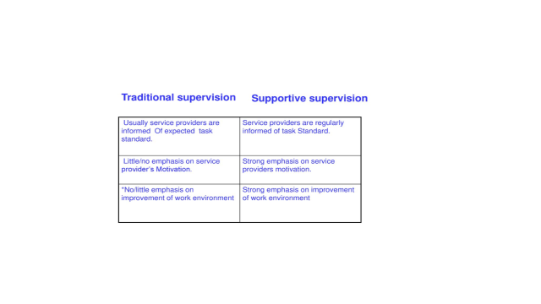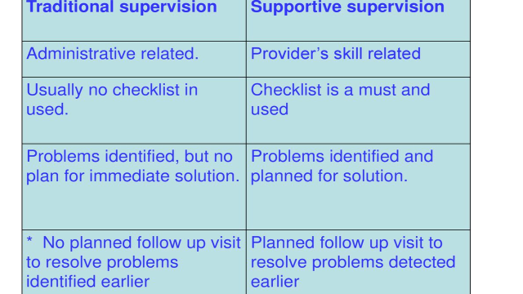

- Highlight 3 differences between coaching and mentoring ( 6 marks)
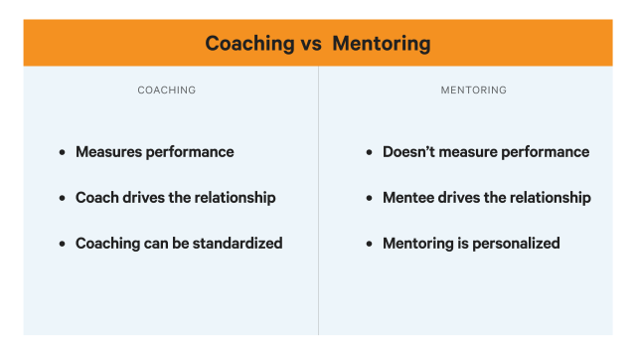
- Enumerate the 4 step approach to effective coaching (4 marks)
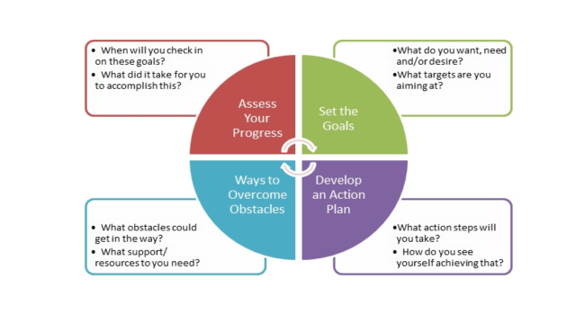
- Briefly highlight the key elements of the Egan’s model of counselling (3 marks)
The current/present
The preferred
Actions/strategies

